**BSc INITIAL REPORT**  
  
Submitted for the  
BSc Honours in Computer Science with Games Development  
  
April 2009  
  
**Particle System for the PSP**  
  
by  
  
**Jamie Sandell**

**Contents**

* 1 - Introduction and Project Brief
  + 1.1 -Introduction
  + 1.2 -Project Brief
* 2 - Analysis of Context and Identification of Tasks
  + 2.1 - What is a Particle System?
  + 2.2 - How a Particle System Works
  + 2.3 - Why a Particle System?
  + 2.4 - Porting to the PSP
  + 2.5 - Alternatives to Achieving the Goal
* 3 - Project Task List and Timescales
* 4 - Project Time Plan
* 5 - Risk Analysis
  + 5.1 – Risk Analysis
  + 5.2 – Risk Strategies
* 6 - Background References
* 7 - Appendix
  + 7.1 - Appendix I
  + 7.2 - Appendix II
  + 7.3 - Figure 1

**1 - Introduction and Project Brief**1.1 - Introduction  
  
The purpose of this initial report is to clearly define and outline my final year project.  
This report will analyse the context of the project and also identify key tasks. These tasks will then be further analysed to accurately assess how long they should take and pinpoint any risks that are involved. This task information is then taken and presented in the form of a Gantt chart so as to clearly outline the timescale of the project. The initial report also contains a reference list of information and sources that are deemed to be key material to the project, and that have been used in this initial report, or, will most likely be used in the future reports of the project. Finally the initial report closes with the appendix page, which contains any relevant information that doesn’t fit in with the main body of text.  
  
1.2 - Project Brief  
Project Code: JHP1  
Title: Particle Engine for PSP.

Specification:  
This project is to produce a particle engine and tool for use on the PSP development kit. This will require the student to use an industry standard PSP development kit and SDK. The project is suitable for a proficient programmer and is ideal for someone hoping to work in the games industry.

**2 - Analysis of Context and Identification of Tasks**  
The ultimate aim and goal of the project is to design and create a fully working particle engine and tool for the PSP development kit. The first piece of analysis that must be done is to actually discover not only just what a particle system is and how a particle system works, but, also, why such a system is required. On-top of this the question must be raised - *how can the project be incorporated onto the PSP and how can it run efficiently on the hardware that the PSP offers*. A broad overview of how this can be achieved must be supplied (See Identification of Tasks). Finally any alternatives to achieve the intended output must be touched upon.  
  
2.1 - What is a Particle System?  
  
A particle system is a “method for modeling fuzzy objects such as fire, clouds, and water. Particle systems model an object as a cloud of primitive particles that define its volume.” (Reeves, 1983, p 1).  
  
2.2 - How a Particle System Works  
  
There are many different approaches to a particle system, however, they all work on the same underlying basic principles, i.e.:

* The particle is generated by an emitter (see Appendix II)
* It’s new position is calculated
* Render the particle
* If it’s at the end of its lifespan it is removed, if appropriate it is reinitialised.

It is how the particle engine does this that makes the effects very different from a different effect, e.g. an explosion effect compared against a rain effect, these effects are completely different but are in fact created using the exact same principles. For instance the emitter can be changed to any emitter type wanted. The calculation of the particle’s new position can involve physics based simulation or stochastic (“*The most common choice is to implement some kind of dynamics to the particles so they mimic real-world phenomena.*”(Dalmau)). Then the particle engine renders the particle, this can be anything that the graphics library supports, e.g. a point or a triangle strip.  
  
2.3 - Why a Particle System?  
  
Why would someone need to program a formal algorithm to create such visual effects, why can’t conventional tools (e.g. Maya 3D) be used to create such an effect and animate it? Well this is answered and explained perfectly by Sabo in his article, he states, “*Particles making up the system are non-static unlike standard geometry objects. Particles are born, they change over time, and then die off. A key point regarding particle systems is that they are chaotic. Instead of having a completely predetermined path, each particle can have a random element, called a stochastic component, which modifies its behavior. This random element is, in fact, the main reason why particle systems are so good at reproducing realistic effects.*”(Sabo).  
  
2.4 - Porting to the PSP  
  
Porting the project to the PSP will not be too difficult, however, converting some graphical commands (OpenGL) will require converting the commands to their equivalent using a graphical library on the PSP.  
The biggest challenge with porting the engine will be getting it to run on the PSP efficiently, it must be kept in mind that the PSP is a handheld device, and as such, when compared to a cutting edge PC, or even an average PC it is lacking in hardware capabilities (See Appendix I). This actually poses a big challenge because a particle system can be displaying literally thousands of particles on the screen at any given timeframe, and not only just drawing them but also calculating their positions.  
  
2.5 - Alternatives to Achieving the Goal  
  
Classically there are two methods of achieving the goal, the first is to code the particle system as a class hierarchy with ParticleSystem as an abstract class and new particles effects (e.g. fire) deriving via inheritance from this parent.  
The second alternative is to “*create a deep, complex particle system class, where individual systems are nothing but data-driven objects that*

*parameterize the class in many ways.*” (Dalmau).  
The plan of action for the project is to actually utilise both methods to achieve the project’s goal. The second method will be utilised first to create the editor (which will be used on a PC); this method is chosen for the editor because once an effect has been edited it will be easy to update the display to show the new particle effect (e.g. a switch statement to select the kind of emitter to use). The editor will then write the effects to a new file which will be in the form of a specified class framework.  
The first method will be the one actually used on the PSP to show the particle effects in action. This method has been chosen for this task because when in a game environment, or any big project environment, it is best to use an Object-Orientated approach as it becomes more manageable and easier to understand (easier to abstract and view high-level concepts).  
  
**3 – Project Task List and Timescales**  
  
#1 Initial Report  
A report outlining the ultimate aims and goals of the project accompanied by a plan and timescale.  
***Duration – 9 days.***#2 Research and Design  
Continue with background research and design the system at a high level.  
***Duration – 3 days.***#3 Prototyping  
Produce a prototype of the project software and assess it externally.  
***Duration – 1 day.***#4 Design  
Go back to the initial design document/(s) and alter according to feedback.  
***Duration – 1 day.***#5 Prototyping  
Alter the prototype accordingly.  
***Duration – 1day.***#6 Unit Implementation  
Code the necessary units.  
***Duration – 42 days.***#7 Unit Testing  
Test all units extensively (white box and black box testing).  
***Duration – 42 days.***#8 Unit Integration  
Integrate the necessary units.  
***Duration – 5 days.***#9 Integration Testing  
Test the integration extensively (white box and black box testing).  
***Duration – 5 days.***  
  
#10 Interim Report  
The interim report is essentially a progress review including any and all revisions, updates, and modifications that need addressing at this stage of the project.  
***Duration – 14 days.***  
  
#11 Final Report  
The final report is and all encompassing document of everything that I have done and achieved during my final year project.  
***Duration – 60 days.***  
  
#12 Project Appraisal  
This is a review of how far successfully I have managed my project and my time.  
***Duration – 14 days.***#13 Presentation  
Preparing and executing the presentation of my final year project.  
***Duration – 28 days.***

**4 - Project Timeplan**See Appendix III  
  
**5 - Risk Analysis**5.1 - Risk Analysis

|  |  |  |  |
| --- | --- | --- | --- |
| **Risk** | **Severity** | **Likelihood** | **Significance** |
| Equipment Failure | High | Low | Medium |
| Cognitive Shortfall | Medium | Medium | Medium |
| Deadline Pressure | High | Low | Medium |

5.2 – Risk Strategies

|  |  |  |
| --- | --- | --- |
| **Risk** | **Evaluation** | **Action** |
| Equipment Failure | If there was any equipment failure then there is a cost to fix it/replace it and in the worse case a loss of data. | Keep version backups of all work on different types of media (including the internet). |
| Cognitive Shortfall | Failing to understand the work is always an issue with anything new and if not combated is quite an issue. | Try my hardest to understand everything, if there is something I don’t understand then I must seek the relevant help until I do. |
| Deadline Pressure | Deadline press is a very severe issue that can cause extreme stress, depression, and ultimately project failure. | Be aware of deadlines and steadily work towards them constantly, do not put the work off. |

**6 - Background References**  
  
Lander J, 1998, *The Ocean Spray in Your Face* [online], Available: <http://www.darwin3d.com/gamedev/articles/col0798.pdf> [Accessed 16th October 2008].  
Dalmau DSC, 2003, *Core Techniques and Algorithms in Game Programming*, New Riders Publishing.  
Reeves TR, 1983, Particle Systems – *A Technique for Modeling a Class of Fuzzy Objects*, SIGGRAPH [online], 17(3), p359. Available: <http://www.lri.fr/~mbl/ENS/IG2/devoir2/files/docs/fuzzyParticles.pdf> [Accessed 16th October 2008].  
Zhang J, Angel E, Alsing P, Munich D, *An Object-Orientated Particle System for Simulation and Visualization* [online], Available: <http://www.cs.unm.edu/~treport/tr/01-06/particle.pdf> [Accessed 17th October 2008].  
VDB John, 2000, *Building an Advanced Particle System* [online], Game Developer, Available: <http://www.mysticgd.com/misc/AdvancedParticleSystems.pdf> [Accessed 18th October 2008].  
Molofee J, *Lesson: 19* [online], Available: <http://nehe.gamedev.net/data/lessons/lesson.asp?lesson=19> [Accessed 17th October 2008].  
Allen M, *Particle Systems* [online], Available: <http://web.cs.wpi.edu/~matt/courses/cs563/talks/psys.html> [Accessed 17th October 2008].  
Latta L, 2004, *Building a Million-Particle System* [online], Available: <http://www.gamasutra.com/view/feature/2122/building_a_millionparticle_system.php> [Accessed 22nd October 2008].  
Sabo M, *Improving advanced particle system by adding property milestones to particle life cycle* [online], Available: <http://www.cescg.org/CESCG-2004/web/Sabo-Miroslav/> [Accessed 22nd October 2008].

**7 - Appendix**7.1 - Appendix I  
  
PSP Hardware Specifications

## CPU

* Allegrex CPU
  + MIPS r4000 32-bit core 1-333mhz
  + 16kib I-Cache & D-Cache
    - 64-byte line length
    - 2-way set associative, LRU
  + No TLB
  + 7-stage pipeline
  + 32 32-bit registers
  + FPU (COP1)
    - 32-bit single precision
    - 32 32-bit registers
    - [IEEE 754](http://en.wikipedia.org/wiki/IEEE_754) compliant
    - Sqrt (28 cycles), div(28 cycles), most others 1 cycle
  + VFPU (COP2)
    - Vector FPU “Macromode only”
    - Designed for vector and matrix ops
    - 128 32-bit registers
      * Reconfigurable as scalar, vector or matrix
      * IEEE 754 Single precision float
    - Can also handle 32-bit int, 16-bit int, 8-bit int, half float
    - vmmul.z vd, vs, vt - 4×4 matrix/vector multiply, 22 cycles
* Media Block CPU
  + MIPS r4000-based core
  + 2MB Embedded DRAM
  + VME - Virtual Mobile Engine
    - Reconfigurable processor to decode audio & video
    - ATRAC3plus & MP3 for music
      * ATRAC3plus & ADPCM for games but not MP3 due to licensing issues
  + AVC H.264 engine
    - MPEG-4 Hardware accelerator
    - Up to 720x480x30fps
      * Libraries support 480x272x29.97fps

## Bus

* Main bus shared by CPU and Graphics Engine
* CPU only has level-1 cache, recomend minimizing memory usage
* Cache miss ~70 cycles
* VRAM read ~44 cycles
  + contention with GE
* Scratchpad read ~38 cycles

## Graphics

* Graphics Engine (GE)
  + 2MB Embedded DRAM
  + Supports Lighting, skinning (8 weights), morphing, subdivision, pixel operations
  + Operates at bus speed (default 111mhz)
  + 3.5GB/s Bus bandwidth
  + 444 Mpixels/sec fill rate
  + 23 Mploys/sec T&L

## Storage

* UMD
  + [UMD 1.8 GiB DISC](http://www.ecma-international.org/publications/standards/Ecma-365.htm)

## Ports

* Serial-Port (RS-232)
  + <http://mc.pp.se/psp/phones.xhtml>
* USB-Port

7.2 - Appendix II  
  
  
“*Particles are created at some kind of emitter, which initializes their parameters. If we want our system to behave in any interesting way,*

*the key is to generate each particle with slightly different initial values, so the behavior rules (which are shared by all particles) make each one look like a unique element.*” (Dalmau)

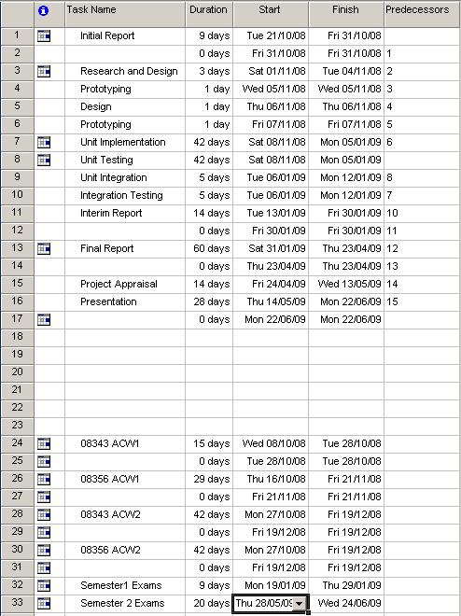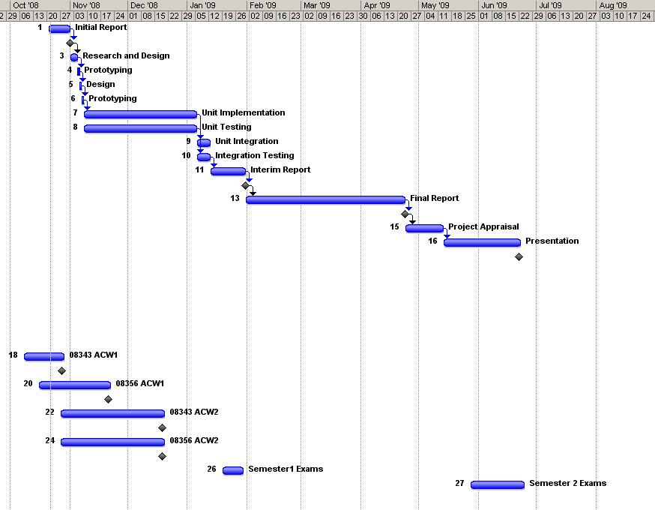

7.3 - Figure 1